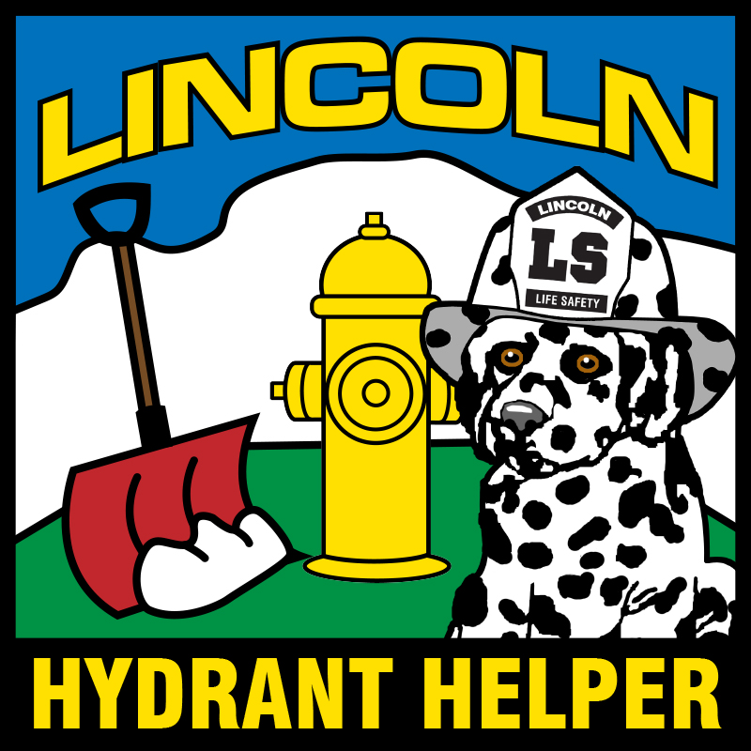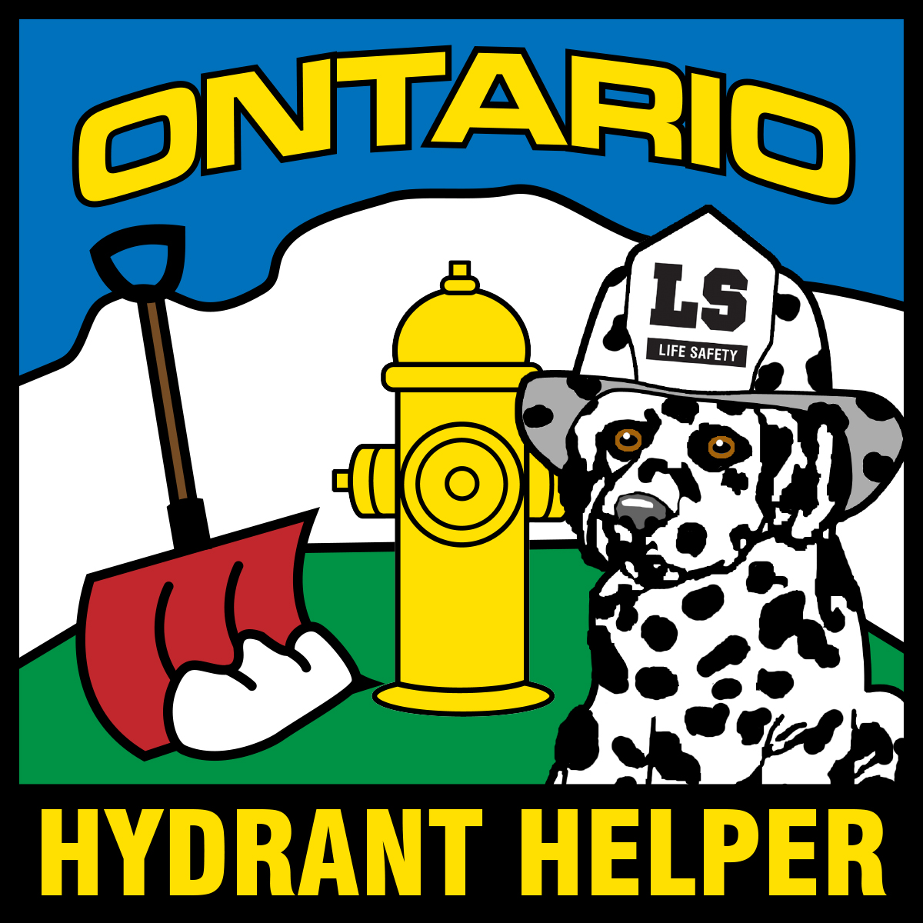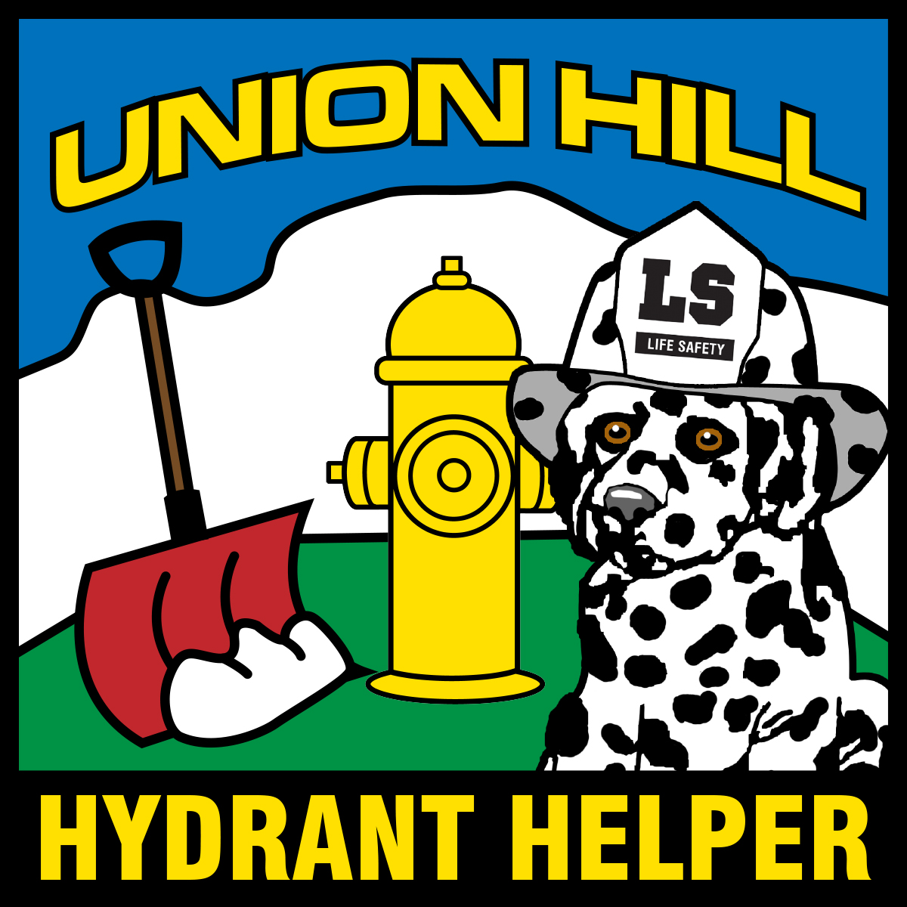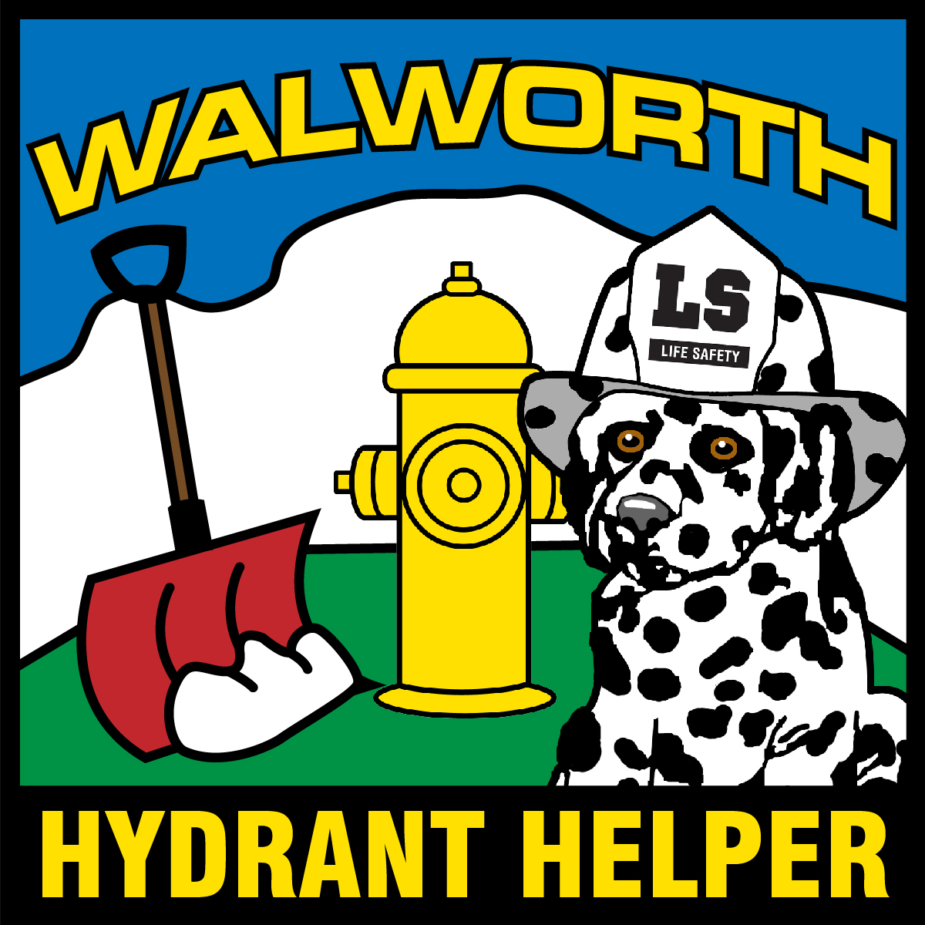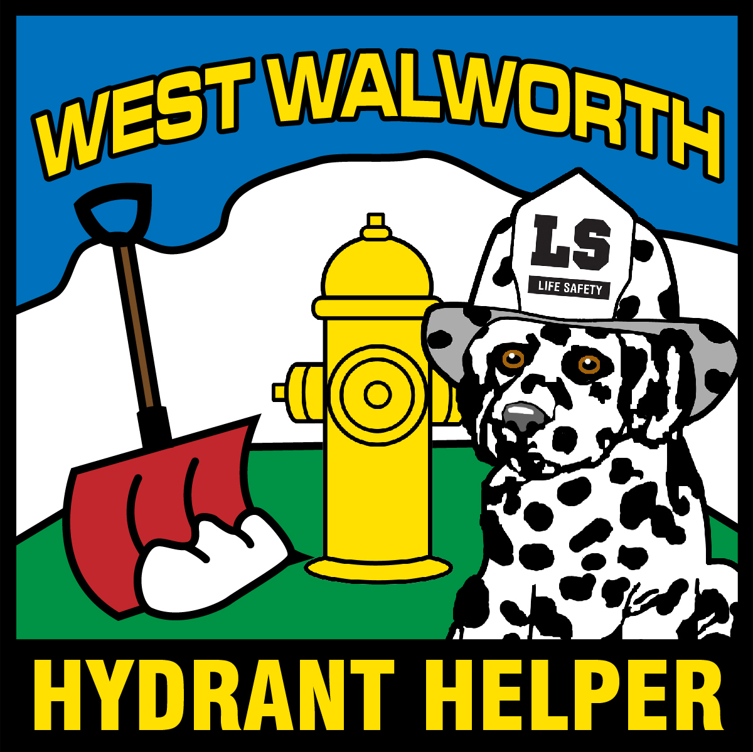
Hydrant Helper Information

Name: ___________________________________________

Location of
Hydrant: ___________________________________________

Home
Address: ___________________________________________

Fire District: Lincoln Ontario Union Hill
Walworth West Walworth
(if you’re not sure we will determine)

I confirm that this person has done a good job being responsible for the Fire Hydrant at the location listed above and is deserving of the title “Hydrant Helper”

Parent/Guardian ___________________________________________

Contact Info ___________________________________________
Phone/Email

Please return this signed form to your school’s front office or:

Lincoln Fire Department
Attn. FFBob
719 Plank Road
Ontario, New York 14519
(315) 524.8493
Or to: FFBOB@rochester.rr.com

Pictures are always welcomed

